Baarabile Faith

[Company name] | [Company address]

sparkBeauty

st10477929

Background and summary for the business:

**sparkBeauty**

Tired of hair products that style your relaxed hair but don’t nourish? I was, too. That’s why I developed this treatment with powerful natural ingredients like argan oil, shea butter, and keratin to combat dryness and breakage. It’s a gentle, all-in-one solution for relaxed hair type, designed to not only enhance your look but also ensure your relaxed hair stays healthy long-term.

Our vision is to deliver a solution that combines aesthetic improvement with the foundation of lasting relaxed hair wellness.

After an extensive period of development and testing, the product was officially launched on the 6th of August 2025. Its release was strategically scheduled to capitalize on rising consumer interest and current market trends.

**Mission Statement:**

sparkBeauty is dedicated to building a world where every hair texture is celebrated. We create natural, nutrient-rich products that transform relaxed hair health, so you can wear your hair with confidence and pride. Nourishing hair. Inspiring confidence. sparkBeauty provides natural, trusted care for every texture.

**GOALS**:

These are the goals for our business in the next 6 months:

Boost sales revenue – set achievable sales targets and work toward consistent revenue growth. Effective tactics that will include launching promotional campaigns, enhancing upselling strategies, and attracting more high-value clients. Consistence that will monitor outcomes to focus on the most profitable approaches.

Reach New Markets – growing my business requires attracting new customer segments. We are considering targeting local ads, social media outreach, referral programs, and partnerships with complementary businesses. Entice new shoppers with first-time buyer’s discounts or referral rewards.

Increase Customer Loyalty- Retaining current customers will be more cost-effective than acquiring new ones. Implement loyalty programs, deliver personalized experience and maintain high product quality to turn satisfied customers into repeat buyers and brand advocates.

Strengthen Digital Visibility – A professional and easily discoverable online presence is essential. Optimize your website for search engine (SEO), maintain active and authentic social media engagement, ensure prompt responses to online inquiries to build trust and authority.

Broaden our offerings – staying competitive by expanding your product or service lines. Introduce new items, enter adjacent services areas. Diversification can mitigate risk and create additional revenue sources.

Optimize financial health - ensure long-term stability through diligent financial oversight. Control costs, negotiate improved supplier terms, and monitor cash flow closely. Regular financial reviews help pinpoint inefficiencies and increase profitability.

Develop Employee Skills - Invest in your team through continuous training and clear paths for advancement. Skilled and motivated employees provide better service, drive innovation, and contribute significantly to overall business success.

Engage With the Community – Build a positive local reputation by participating in community events, supporting local causes, and forming foster brand loyalty and create a dedicated customer base.

and finally Executing a long-term vision – plan with ambitious yet realistic goals. Whether it’s expanding to new locations, franchising, or entering different markets, a clear strategic roadmap is vital for sustained growth and competitiveness.

**OBJECTIVES:**

1. Pursue Sustainable Growth

Prioritize consistent and controlled expansion over rapid scaling to ensure quality is maintained and operations remain stable.

2. Deepen Customer Relationships

Focus on retaining and growing the existing loyal customer base through repeat engagement and referral programs, while also strategically acquiring new clients.

3. Capture Greater Market Share

Strengthen the business's position by increasing its dominance within its local area or niche market, effectively outpacing competitors.

4. Broaden Revenue Streams

Reduce risk and unlock new opportunities by diversifying the range of products or services offered to meet evolving customer demands.

5. Streamline Business Operations

Improve productivity and reduce costs by optimizing internal processes, eliminating inefficiencies, and implementing modern technology.

6. Sustain a Competitive Edge

Continuously analyze the competitive landscape and refine unique selling propositions in areas like value, quality, or customer service to stay ahead.

7. Build upon Brand Equity

Leverage existing market presence to further strengthen the brand's reputation for trustworthiness, quality, and customer commitment.

8. Invest in Your Team's Growth

Cultivate a skilled and dedicated workforce by providing ongoing training, leadership opportunities, and a positive work environment.

9. Remain Agile and Responsive

Stay relevant by proactively adapting to new technologies, emerging consumer trends, and shifts within the industry.

10. Ensure Financial Resilience

Secure the company's long-term future by maintaining healthy cash flow, reinvesting profits wisely, and building financial buffers for stability.

**Technical requirements:**

HTML, CSS and JavaScript.

**budget**

|  |  |  |
| --- | --- | --- |
| CATEGORY | EXPENSE ITEMS | ESTIMATED MONTHLY |
| Fixed costs | * Rent * Utilities (water, electricity and internet * Insurance | R12,800  R3,000  R925 |
| Variable costs | * Hair products and suppliers * Equipment maintenance * Packaging and branding | R9,250  R1,200  R1,830 |
| Marketing and promotion | * Social media advertising * Website maintenance/online store * Flyers, posters, loyalty cards | R2,300  R555-R1,850  R500-1,200 |
| Emergency fund | * Reserve for repairs and slow seasons | R1,850-R4,500 |
| Professional services | * Accounting and bookkeeping * Licensing and permits renewal * Training and workshops | R925-R2,300  R370-925  R925-R1,850 |

**Current website analysis:**

Strengths:

Intuitive Navigation: Easy-to-use menus and logical layout.

Mobile compatibility: Flawless performance on all device types.

Rapid load times: Quick loading to reduce user abandonment.

Cohesive branding: Consistent use of visuals to build trust.

High-Quality contest: Relevant and valuable information for users.

Weaknesses:

Low accessibility: non-compliance with standards for users with disabilities.

Outdated design: cluttered pages with excessive elements that create a poor user experience.

Slow performance: unoptimized content that hinders speed, especially on mobile.

Poor SEO: lack of basic optimization, reducing search engine visibility.

Inadequate security: absence of features like HTTPS, eroding user trust.

**Timeline and milestone of sparkBeauty:**

Planning and branding (March-April 2025)

* The name sparkBeauty was selected to evoke radiance, self-assurance, and sophistication
* Final packaging designs featured white bottles complemented by gold and black details.

Product development (May-June 2025)

* The initial range was introduced, including Shampoo, conditioner, Hair oil and a leave-in treatment
* Formulas enriched with shea butter and argan oil were perfected through testing on relaxed hair.

Pre-launch setup (July 2025)

* The official store went live in Pretoria east- Lynne
* Samples were sent influencers for reviews

Launch (6th of august 2025)

* Official product launch event (in- person).
* Special promotions for first customers.

Growth & Expansion (January 2026)

* Planning to expand sparkBeauty line with deep treatments & styling creams.
* Built partnerships with hair salons and beauty supply stores.
* Launching loyalty rewards program for repeat customers.

**Design and user experiences**

Color scheme: white with a touch of gold and black details

Typography: Roboto and open sans, typeface/font and line spacing, letter spacing and alignment.

Layout and Design: Balance and Alignment, white space, visual hierarchy

User experience considerations: Usability, Accessibility, consistency, navigation and information architecture and performance and speed.

Develop low-fidelity wireframes to visualize the website’s layout and information hierarchy:

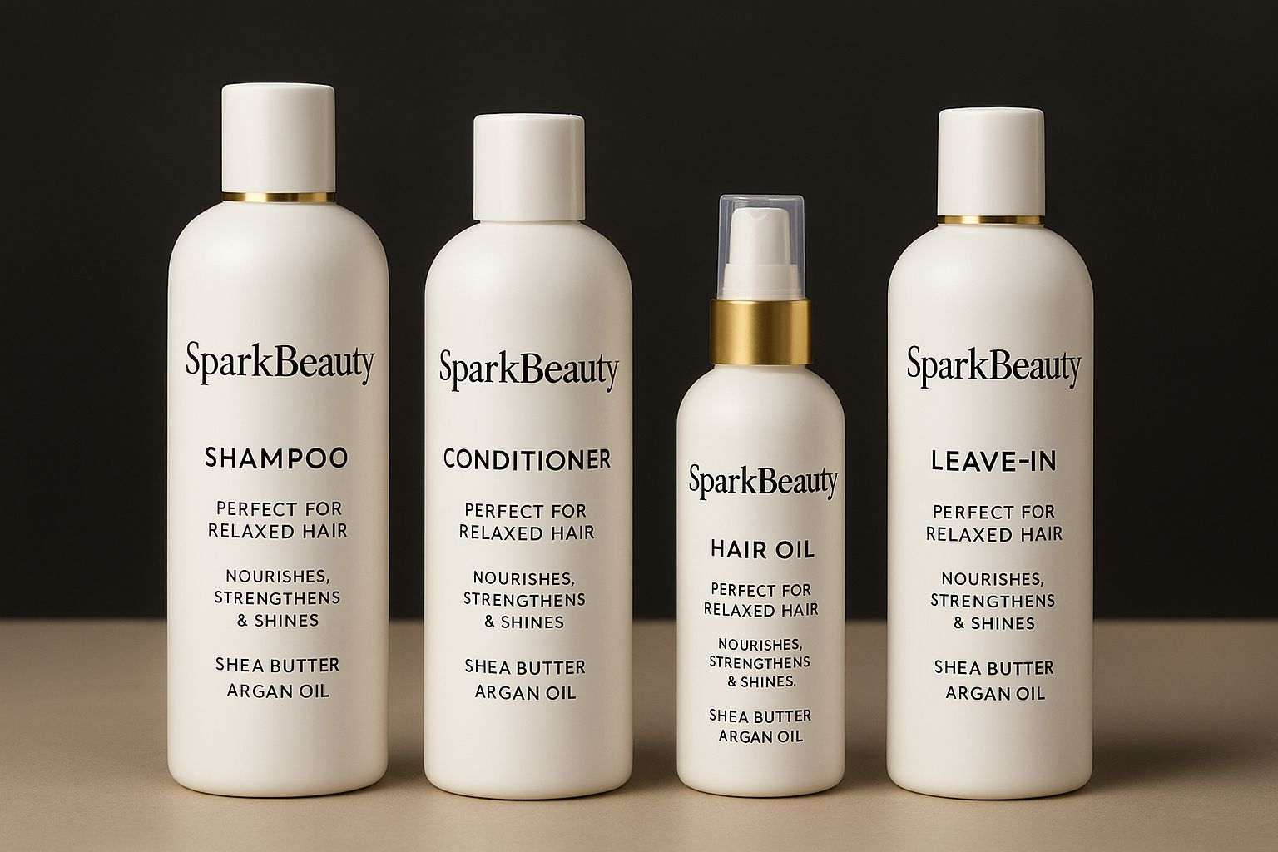**Picture of my product:**

# References

Consortium. Available at: https:// [www.w3.org/TR/WCAG21/](http://www.w3.org/TR/WCAG21/) (Accessed: 23

August 2025).

**References (Harvard Style)**

• Dean, B. (2020) SEO site speed: Why it matters and how to improve it. Backlinko.

Available at: <https://backlinko.com/page-speed-seo> (Accessed: 23 August 2025).

• Fishkin, R. (2015) The art of SEO. 3rd edn.

Sebastopol: O'Reilly Media.

• Google (2020) Mobile-friendly websites.

Available at: https: //developers.google.com/ search/mobile-sites (Accessed: 23 August 2025).

• Krug, S. (2014) Don't make me think: A commonsense approach to web usability.

3rd edn. Berkeley: New Riders.

• Nielsen, J. (2012) Usability 101: Introduction to usability. Nielsen Norman Grou**p.**

Available at: https:// www.nngroup.com/ articles/usability-101-introduction-to-usability/ (Accessed: 23 August 2025).

• W3C (2018) Web Content Accessibility